Project Design Phase-II
Data Flow Diagram & User Stories

Date | 28-11-2025
Team ID
Project Name | Flight Booking System
Maximum Marks | 4 Marks

Data Flow Diagrams:
A Data Flow Diagram (DFD) visually represents how information moves throughout the Flight Booking System.
It outlines how different users—such as Passengers, Admins, and Airline systems—interact with the platform, how flight data is exchanged within various modules, and how bookings and passenger records are stored.

DFD Level 0 – Flight Booking System
The Level 0 DFD gives a top-level view of the Flight Booking System by illustrating how data flows between the system and external entities.
It represents the entire application as a single core process and highlights how passengers, administrators, and airline systems send and receive information while performing flight searches, bookings, updates, and other related operations.

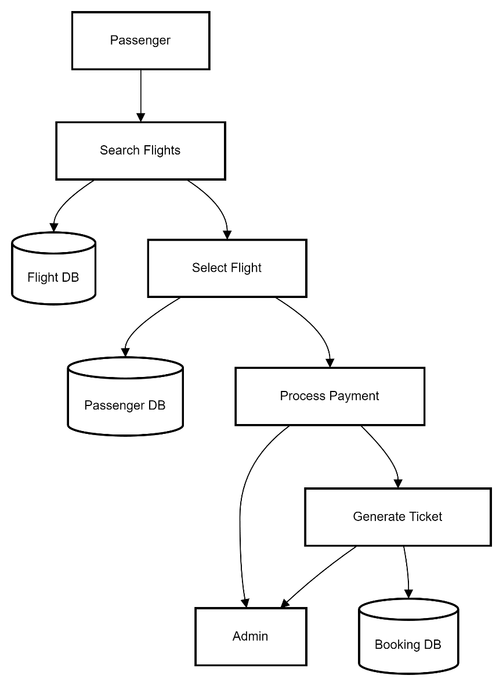

User Stories– Flight Booking System
User Type | Functional Requirement | User Story / Task | Acceptance Criteria | Priority | Release
Passenger | Flight Search | As a passenger, I want to search flights by selecting travel dates, origin, destination, and number of passengers. | The system should display accurate flight options based on the chosen filters. | High | Sprint-1
Passenger | Flight Selection | As a passenger, I want to choose a flight and view full details such as fare, airline, timing, and available seats. | The selected flight should load correct fare details and current availability. | High | Sprint-1
Passenger | Passenger Details & Seat Selection | As a passenger, I want to enter traveler information and select my preferred seats. | Traveler details must be saved and the seat selection map should display properly. | Medium | Sprint-2
Passenger | Booking & Payment | As a passenger, I want to complete my booking through a secure online payment process. | Payment must be successful and a PNR/ticket should be generated instantly. | High | Sprint-2
Passenger | Booking History | As a passenger, I want to view a list of all my previous bookings. | The system must show accurate records of all past bookings. | Low | Sprint-3
Admin | Flight Management | As an admin, I want to add, modify, or delete flight schedules, pricing, and seat availability. | Updates must reflect immediately throughout the platform. | High | Sprint-1
Admin | Booking Monitoring | As an admin, I want to view all booking activities done by passengers. | The admin dashboard must show complete, up-to-date booking information. | Medium | Sprint-2
Admin | User Management | As an admin, I want to manage passenger accounts and resolve their issues. | User profiles must be updated correctly and issue logs maintained. | Medium | Sprint-3
Airline System | Real-time Flight Info | As an airline system, I want to push real-time availability, fare, and schedule data to the platform. | The system must receive real-time flight and fare updates accurately. | High | Sprint-1

